

|  |  |  |
| --- | --- | --- |
| **DAO1704X/DSC1007X - Decision Analytics Using Spreadsheet**  **Group Project** | | |
| **Submitted by:** | Tutorial Q3 Team 2 | |
| **Team Members:** | Carel Ong Shi Ting | A0157667M |
|  | Jayne Ng Su Hui | A0157760Y |
|  | Ong Wen Xuan, Denese | A0156929M |
|  | Roxanne Moh Jia Yu | A0185900E |
|  | Samantha Kang | A0189027X |
|  | Yip Mei Ting Salena | A0169707R |

## 1. Introduction

Mdm Toh is a self-made baker and loves making homemade kuehs for her friends and family. Currently, she makes ondeh-ondeh and ang ku kueh out of her own kitchen for sale. Her kuehs are often well-loved by her customers and they have been promoting it through word of mouth. She is however limited by her small customer base and manpower constraints.

Recently, she got to know about the story of a senior entrepreneur through a television programme. She was inspired and started thinking if she should expand her business since she has been receiving many positive feedbacks from her customers. To do so, she is contemplating between three main options:

1. Continue baking in her own kitchen by herself; remain status quo
2. Hire another friend as full-time to bake together
3. Expand her reach by selling her kuehs at a provision shop

Mdm Toh has decided to pick the option that will provide her with the highest earnings per month.

## 2. Decisions

***Option A - Continue baking by herself***

As Mdm Toh’s kueh are popular to her consistent customer base for a long time, she could choose to continue earning a tidy sum without changing her business model. Currently, Mdm Toh is selling her kuehs at $2 per serving. Taking into consideration of her current constraints,she predicts that the number of orders per month would follow a normal distribution with mean 1500 and standard deviation 250, where the number of orders is given by a the minimum value between the demand from her customers and the number of orders she can take, i.e.

The ingredients follow a uniform distribution ofmean 150 and standard deviation of 350 as the costs of the raw ingredients fluctuates periodically depending on the season.

Table 1: *Estimated costs per month for Option A.*

|  |  |  |  |
| --- | --- | --- | --- |
| Fixed cost | | Variable cost | |
| Utilities | $100 | Ingredients | U~(150,350) |

***Option B - Hire another friend to bake together full time***

Mdm Toh is thinking of increasing the number of orders she can take in but lacks the manpower to do so. Hence, she decided to ask her friend Aunty Mary for help as she is experienced at making kuehs. Mdm Toh is offering Aunty Mary $500 per month and on top of her salary, she will be getting incentives based on the total sales of that month. (Table 2)

*Table 2: Aunty Mary’s fees.*

|  |  |  |  |
| --- | --- | --- | --- |
| **Revenue per Month (SGD)** | *0 - 3500* | *3501 - 5000* | *5001 - 6500* |
| **Fee** | 0% incentive | 10% incentive | 15% incentive |

After hiring Aunty Mary, the number of monthly orders that Mdm Toh increases and follows a normal distribution with mean 2500 and standard deviation 250. However, Mdm Toh’s costs would increase as she would have to prepare extra ingredients and the kitchen for Aunty Mary. The estimated costs for this option can be found in Table 3.

*Table 3: Estimated costs per month for Option B.*

|  |  |  |  |
| --- | --- | --- | --- |
| **Fixed Costs** | | **Variable Costs** | |
| *Utilities* | $150 | *Ingredients* | U~(200,400) |
| *Machinery* | $100 |  |  |

***Option C - Sell in provision shops***

A friend of Mdm Toh suggested that she should start selling her kuehs at a nearby provision shop. By doing so, she is able to reach out to more people and thus expects a greater number of orders for her kuehs. As such, she expects to take in more orders which increases her fixed cost for utilities to $200 and variable ingredient costs to follow a uniform distribution from 200 to 400. The monthly number of orders she takes follows a normal distribution with mean 2000 and standard deviation of 300 now.

*Table 4: Estimated costs per month for Option C*

|  |  |  |  |
| --- | --- | --- | --- |
| **Fixed Costs** | | **Variable cost** | |
| *Utilities* | $200 | Ingredients | U(200,400) |

Furthermore, she now incurs an additional variable cost for the rental of the space used to sell her kuehs, of $500. Due to this additional cost, she decides to change her pricing strategy to follow the state of the economy. The probability of the state of the economy and the selling price are presented in Table 5.

*Table 5: Selling Price of Kueh for Option C*

|  |  |  |
| --- | --- | --- |
| **State of economy** | **Selling Price of the kueh** | **Probability** |
| Poor | $2.50 | 0.3 |
| Average | $3 | 0.5 |
| High | $3.50 | 0.2 |

## 

## 3. Report Analysis

Based on the excel simulation, Option C will give Mdm Toh the highest expected monthly earnings, followed by option B, and option A. However, that alone is not enough for Mdm Toh to make a decision on what option to choose. She has to look at the variance of the monthly earnings for each option which is representative of the amount of risk the options entail to. This can be seen from the spread of the histograms for each option below. We can see that the spread of the monthly profits is largest in option C giving rise to the largest risk.

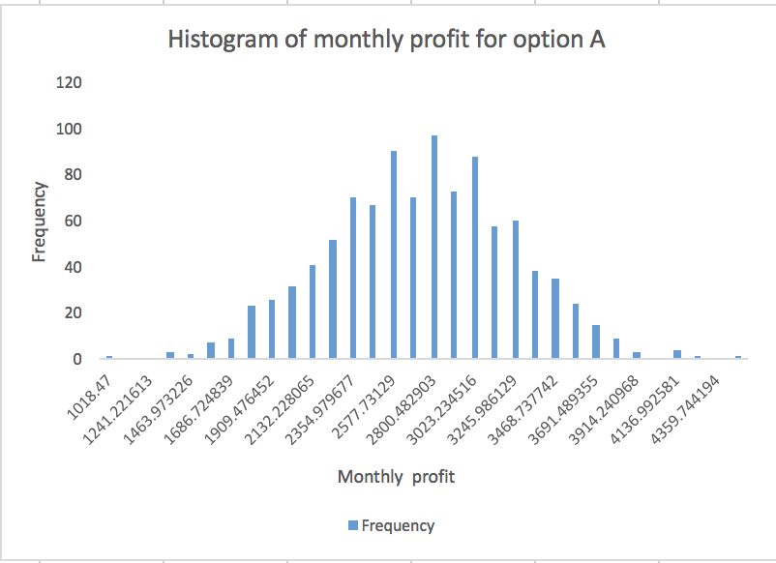 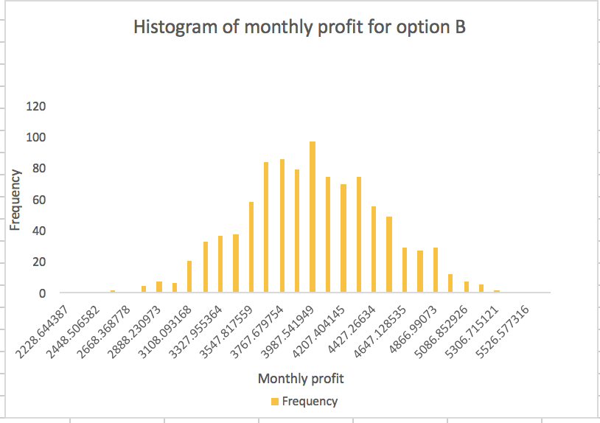

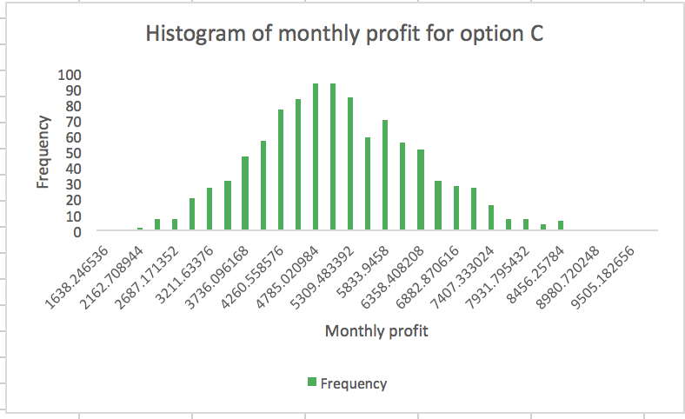

*Table 6: Mean, Standard Deviation, Maximum and Minimum for each option.*

|  |  |  |  |  |  |
| --- | --- | --- | --- | --- | --- |
| **Option** | **Expected Monthly Earnings** | **Standard Deviation** | **Maximum** | **Minimum** | **Risk-Reward** |
| **A** | $2679.03 | $507.25 | $4471.12 | $1018.47 | Medium Risk-Low Reward |
| **B** | $3953.92 | $482.90 | $5299.48 | $2629.48 | Low Risk-Medium Reward |
| **C** | $4995.80 | $1203.98 | $9767.41 | $1638.25 | High risk-High reward |

As Mdm Toh’s main deciding factor is based on achieving the highest expected monthly earnings, she will choose Option C. However, if Mdm Toh is not a risk-taker and weighs out the associated risks for each option, she may decide on choosing Option B instead.

## 4. Sensitivity Analysis and Recommendations

However, we should also consider the variability in the rental costs due to unforeseen changes in the economy. In fact, rental costs are on the rise as landlords often have to keep up to the increasing property taxes, maintenance and market rates. As such, in our sensitivity analysis, we decided to vary the variable rental costs and examine the effect it has on the expected profit.

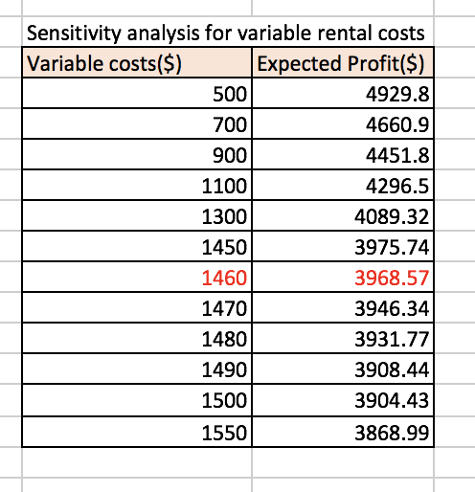

From the table, we can see that as long as the rental costs is kept to a maximum of $1460, option C will still remain as the best option as it generates a larger expected profit of $3968.57, as compared to the other options. However, if the rental costs increase above $1460, Mdm Toh should not consider option C as it generates lesser profit when compared to option B - hiring her friend to bake full time, which generates a relatively larger expected profit of $3953.92.

Previously, Mdm Toh faces a fixed pool of customers which were highly dependent on word of mouth as well as returning customers. However, as she ventures into selling in provision shops, the number of orders she receives now may vary as her business is able to reach out to more customers now. As such, we decided to vary the mean of the distribution of the number of monthly orders mean as well.

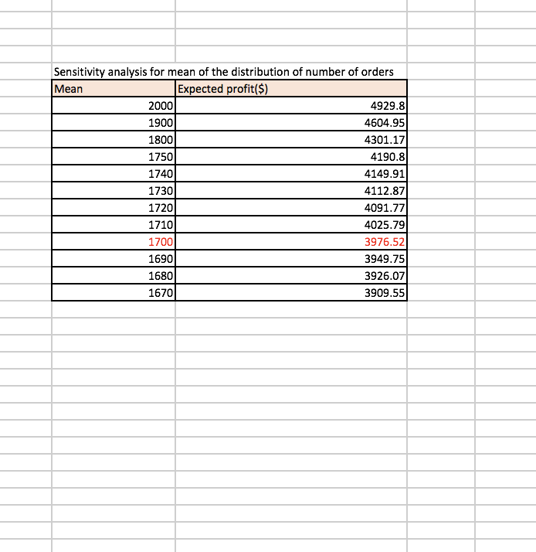From the table, we can infer that as long as the mean of the distribution of number of orders is kept to a maximum of 1700, option C remains to be the best option as it generates a larger expected profit of $3976.52. However, if the mean increases above 1700, Mdm Toh should hire her friend to bake full time with her to generate a larger expected profit of $3953.92.

## 

## 5. Conclusion

In conclusion, Mdm Toh is most likely to choose Option C if her main objective is to increase her earnings as this option provides her with the highest expected monthly earnings of $4995.80. However, in choosing Option C, her actual monthly earnings will be affected by varying rental cost and number of orders and her business is more prone to a high risk, as compared to choosing other options. For instance, her monthly earning will decrease if the rental cost increases beyond $1460 and she'll also need to hire additional manpower if the number of orders exceeds 1700.

Instead, if Mdm Toh wants to minimize risk, Option B will be a better choice for her business as it provides her with a decent monthly earning of $3953.92, at a considerably low risk which we can infer from as Option B’s standard deviation is the lowest. In doing so, Mdm Toh can fulfill her desires of expanding her business and thereby increasing her monthly earnings.